ROCS—Staff Initiator User—Guide

The following Staff actions are submitted into ROCS under Position Management (Orange) Tab as Initiator:
- Classify a New Position
- Equity/Market Review
- Fill A Vacancy
- Reclassify an Existing Position
- Salary In-Grade Adjustment Request
- Self-Initiated Reclass – MGMT Approval Required
- Job Description Review

You will need the following:
If submitting a reclass you will need:
- Approved ERF
- Current CARF
- New CARF (with all new duties/task highlighted in yellow for ease of review)
- Justification Letter
- Org Chart
- SEBS-HR reclassification form

If submitting a Salary In-grade you will need:
- Approved ERF
- New CARF (with all new duties/task highlighted in yellow for ease of review)
- Justification Letter
- Org Chart
- Signed Salary-In Grade form
*For additional information please review SEBS-HR Glossary of Actions

How to:
- Log into ROCS using NETID
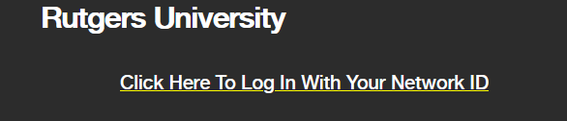

- Select Initiator-User Group under the Position Management Tab.
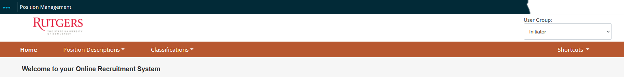

- Click on “Staff” under “Position Descriptions’” drop down menu.
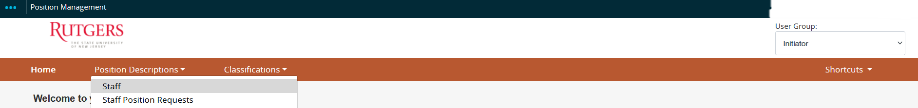

- To create all staff actions (see list above), click on “Create New Position Description”.
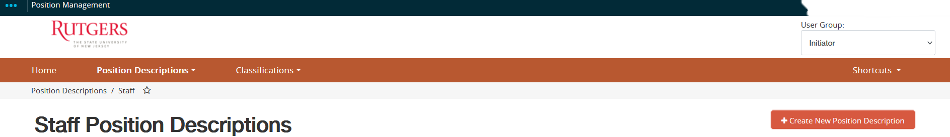

- After inserting the Position Request Description, click on “Start Position Request”.
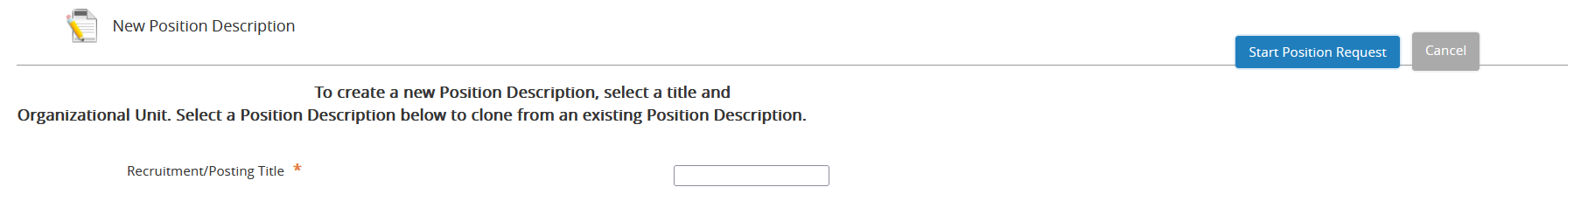

- Use the “classification – filter” to search for the Classification Title.
  - You may use a job code or position title to filter search.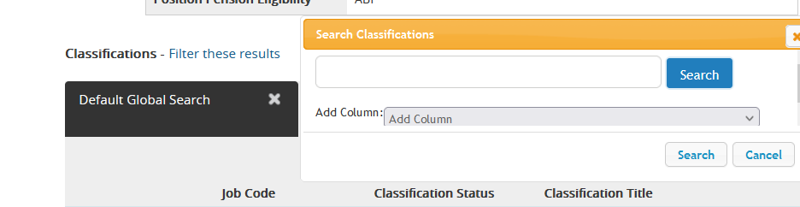

  - Select the classification then click on, “save & continue”.

*Note: Please insure you are saving your progress. Failure to do so will erase all information.

- Indicate the type of action you are submitting.
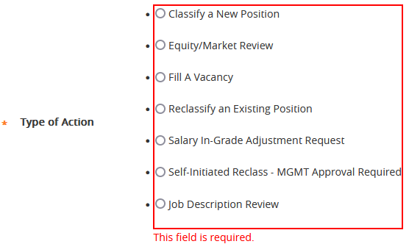

- If reclassifying a position, please fill in the sections below. Under “Departmental Comments” briefly (in one or two sentences) indicate the reasoning for reclass.
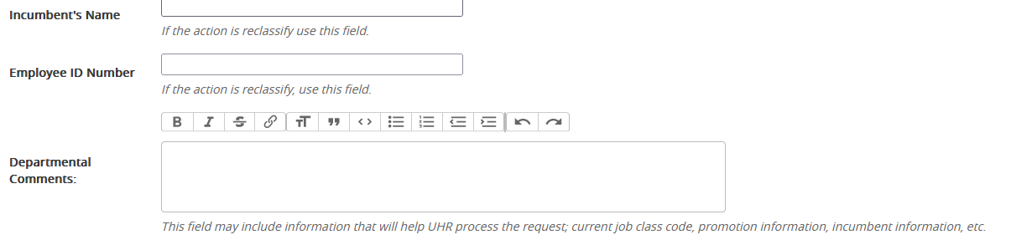
- If filling a vacancy, please include incumbent’s name and EEID, county (or department), last salary and effective date of resignation under “Departmental Comments”

- Please use the corresponding CARF to fill in the General Information, Position Information, Qualifications, Key Duties & Responsibilities, Level of Decision Making, and Scope & Impact sections.
*Note: the sections above must be filled in. Please see example below:

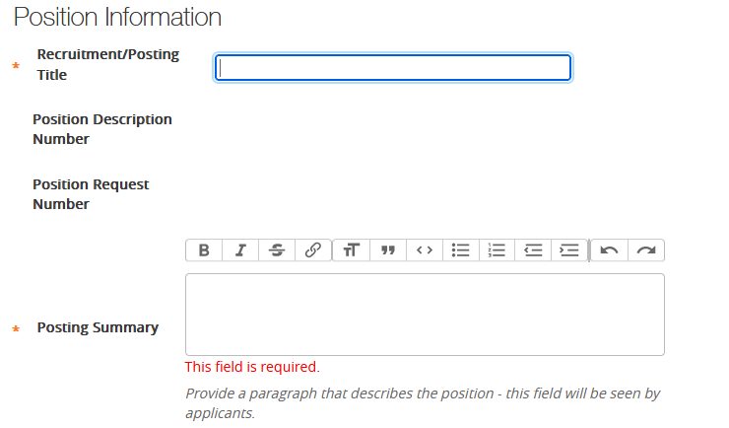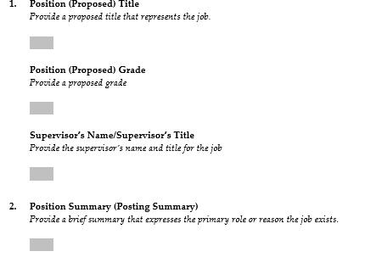

*Note: You do not need to fill out the Banner Positions Only

- Click on “Add Key Duties & Responsibilities” to add each duty listed on the CARF.
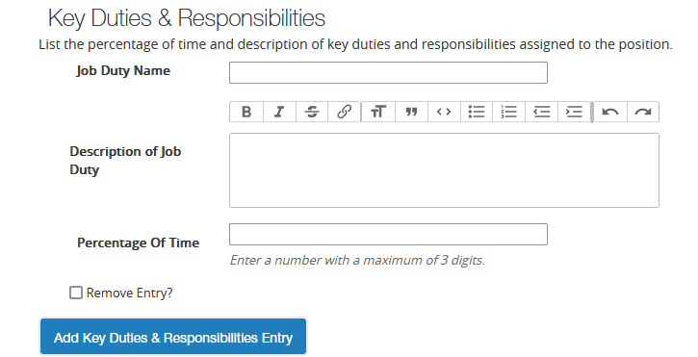

*Note: Please insure you are saving your progress. Failure to do so will erase all information.

- Click on “Add Position Budget Information Entry” to add the position’s budget information. You will need the account’s name, account/index number, and funding information (is it state funded, non-state funded, or grant funded)
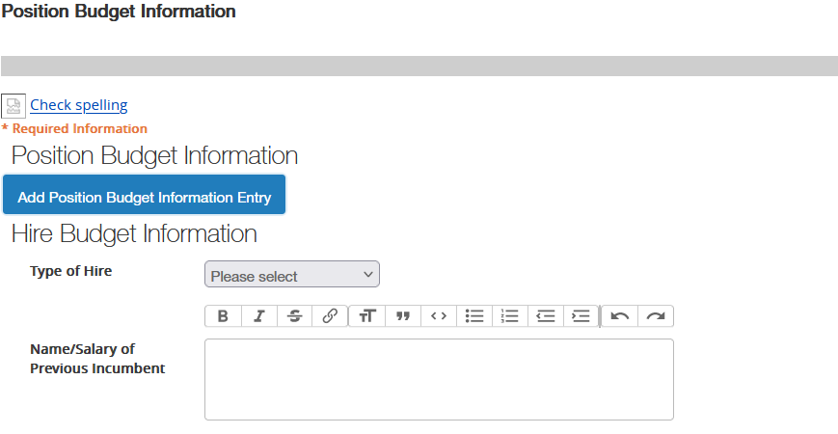
  - If this position is a replacement position, please include the name/salary of previous incumbent
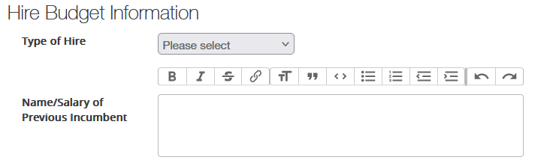

- Upload the required documents
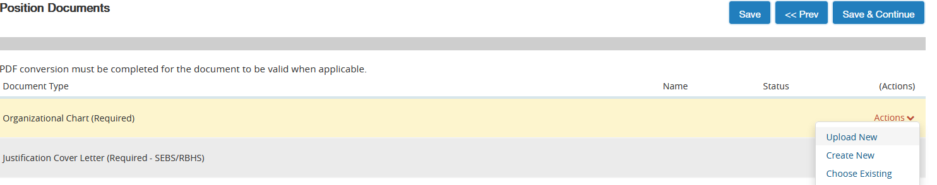

- Review posting before moving in workflow

- After reviewing posting summary, please refer to the ROCS workflow chart and approval routing list for guidance on who to move the posting to next (can also be found our website)

